| 1 | 5 | 8 |
| --- | --- | --- |
| 2 | 4 | 7 |
| 6 |  | 3 |

| 1 | 5 | 8 |
| --- | --- | --- |
| 2 | 4 | 7 |
|  | 6 | 3 |



| 1 | 5 | 8 |
| --- | --- | --- |
| 2 | 4 | 7 |
| 6 | 3 |  |
| 1 | 5 | 8 |
| 2 |  | 7 |
| 6 | 4 | 3 |



| 1 | 5 | 8 |
| --- | --- | --- |
| 2 | 4 |  |
| 6 | 3 | 7 |
| 1 | 5 | 8 |
|  | 2 | 7 |
| 6 | 4 | 3 |
| 1 |  | 8 |
| 2 | 5 | 7 |
| 6 | 4 | 3 |
| 1 | 5 | 8 |
| 2 | 7 |  |
| 6 | 4 | 3 |

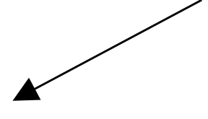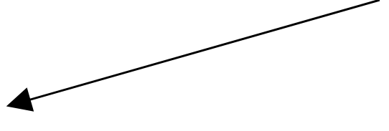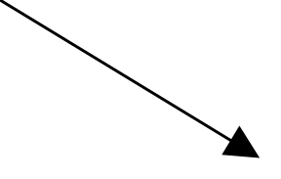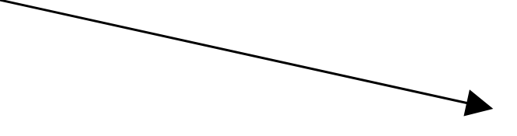

| 1 | 5 | 8 |
| --- | --- | --- |
|  | 4 | 7 |
| 2 | 6 | 3 |
| 1 | 5 | 8 |
| 2 | 4 | 7 |
| 6 |  | 3 |
| 1 | 5 | 8 |
| 2 | 4 | 7 |
| 6 |  | 3 |
| 1 | 5 | 8 |
| 2 | 4 | 7 |
| 6 |  | 3 |



